FAITH FORMATION SCHEDULES 2023-2024 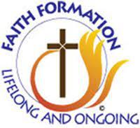

9/17 First Class which will be a guest speaker after 10:30 mass, followed by ice cream in the parking lot!

10/1 2nd class
10/15 3rd class
10/29 Fall Festival "Trunk-or-Treat" parking lot
11/5 5th class
11/19 6th class
12/3 7th class
12/17 8th class
1/7 9th class
1/21 10th class
2/4 11th class
2/11 12th class
3/3 13th class
3/17 14th class
4/7 15th class
4/14 16th class
5/5 1st Communion St. Charles 10:30am 17th class for all but 2nd grade
5/12 1st Communion St. Patrick's 9am
5/19 Last Class (another community gathering)
This is our class schedule to begin the year. We will be adding a few dates for either guest speakers or service projects. We will give you ample notice for both.

Grades K-6 will meet at Bishop Ludden from 9:15-10:15am giving time to go to 10:30am Mass.

Grades 7,8 and Confirmation 1 and 2 will meet from 11:30-12:30 also at Bishop
Ludden.

